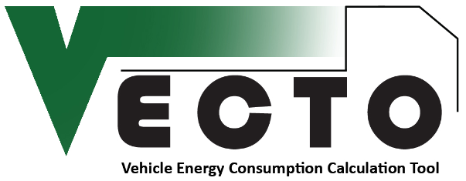

Declaration Results
Date:
Mission:
HDV Class:

Declaration Results
Reference Loading
Loading:
Average Speed:
Fuel Consumption

CO₂ Emissions

Empty Loading  Loading:  Average Speed:  Fuel Consumption  CO₂ Emissions | Full Loading  Loading:  Average Speed:  Fuel Consumption  CO₂ Emissions

